**CONTROLOTRON (SIEMENS) CLAMP-ON FLOWMETER SETUP**

**For 24 Hour 7 Day Technical Support, call Siemens at 1-800-241-4453 or 1-800-333-7421.**

1. It will look similar to what’s below except for a single pair of transducers will be used. Instead of 4, only 2.

2. Transducers must be a matched pair (saying A on one and B on the other).

3. For Pipe-Transducer sizing and spacing see instructions below.

4. Upstream and Downstream cables are labeled accordingly for ease of use.

5. Use motorcycle/4-wheeler straps instead of metal clamps shown below.

6. Put enough grease on the bottom of transducers to cover it. How much really doesn’t matter.

7. Offset transducer bracket setup from the 12 o’clock position. How much doesn’t matter. The only reason for this is so the signal doesn’t bounce off sludge, welds, water, or odd pipe wall on the bottom of the pipe.

8. **THIS FLOW METER WILL ONLY WORK ON PRESSURES ABOVE 125 PSI ON STEEL PIPES.**

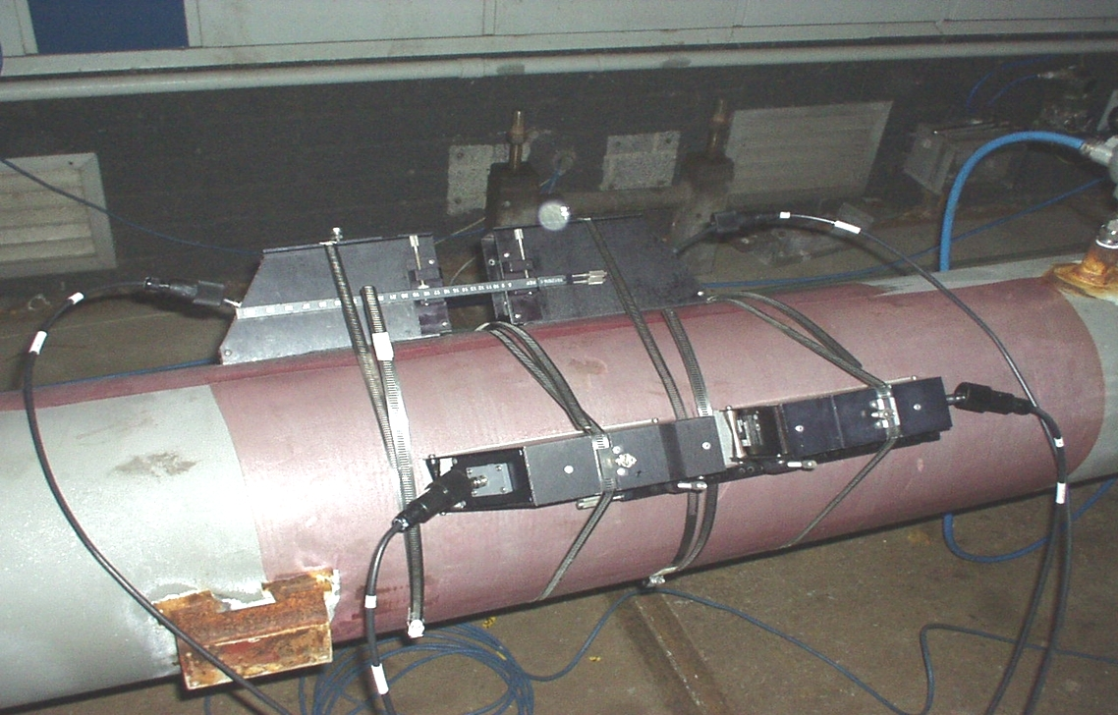

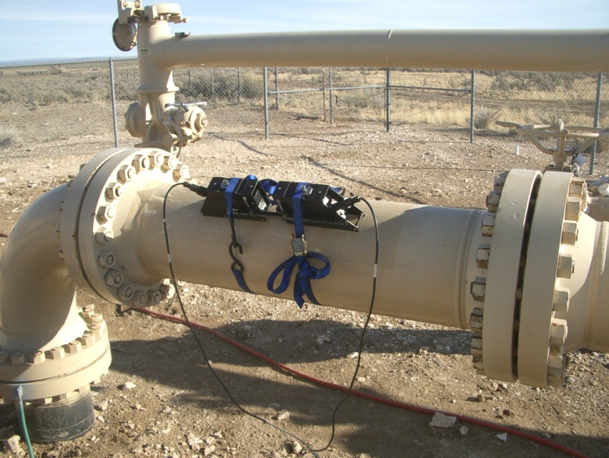 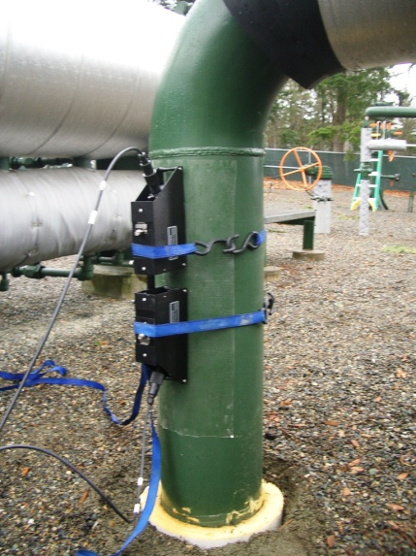

**SOFTWARE SETUP**

1. Turn flow meter on by plugging it in. No on/off button on the meter. You just need a power source from anywhere like a vehicle cigarette lighter or a generator.

2. Hit “Menu” key and it will take you to the screen below

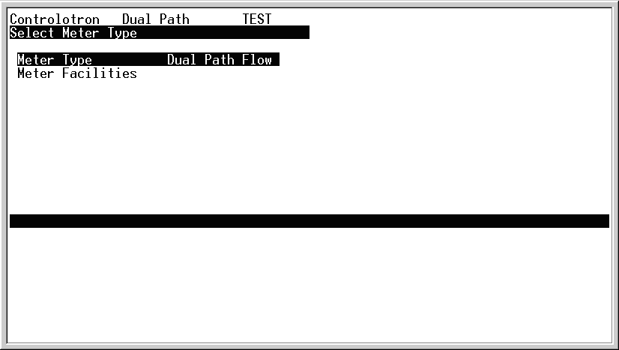

3. Hit “Right Arrow” button twice for screen below

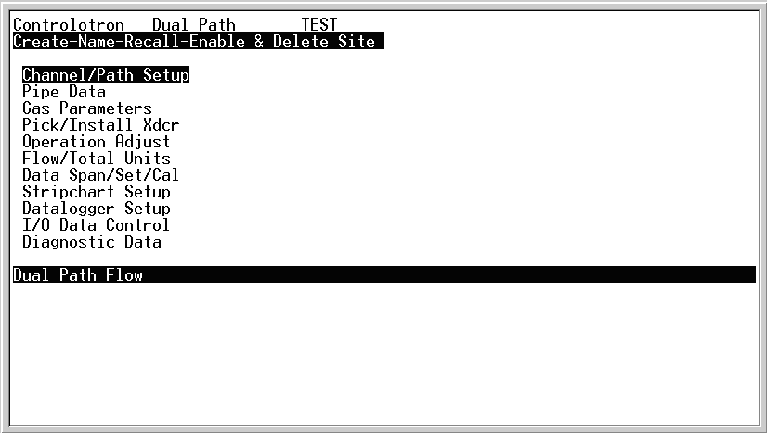

4. Hit “Right Arrow” button for screen below

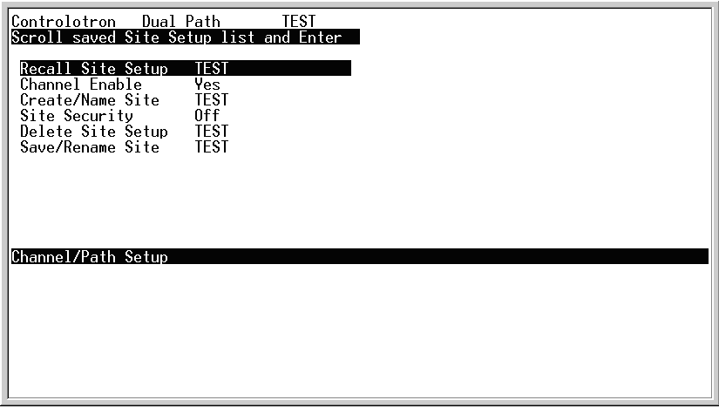

1. Hit “Down Arrow” button to “Create/Name Site”
2. Hit “Right Arrow” button to put a name on the site
3. Hit “Up Arrow” button for the alphabet and Down Arrow for numbers or use numeric keypad

There’s no alphabetic key pad so you have to scroll through the alphabet for the letters.

Hit “Enter” when you’re done. Any other button will make you retype it again.

9. You can also hit “Recall Site Setup” for a site previously setup on the machine. Scroll to the desired site name & press ENTER

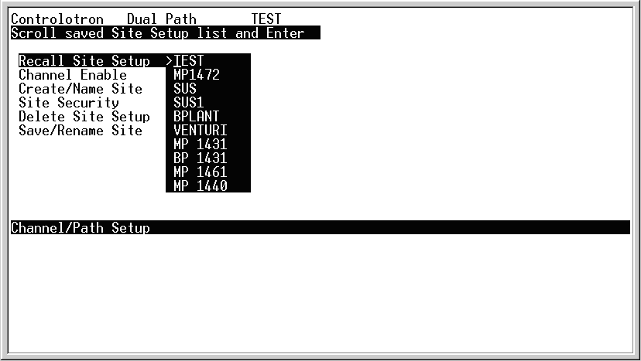

10. Hit “Left Arrow” to get out of this screen. Now you are at the main menu screen you started at (3 pictures above this text).

11. “Down arrow” to “Pipe Data” and hit “right arrow” for screen below.

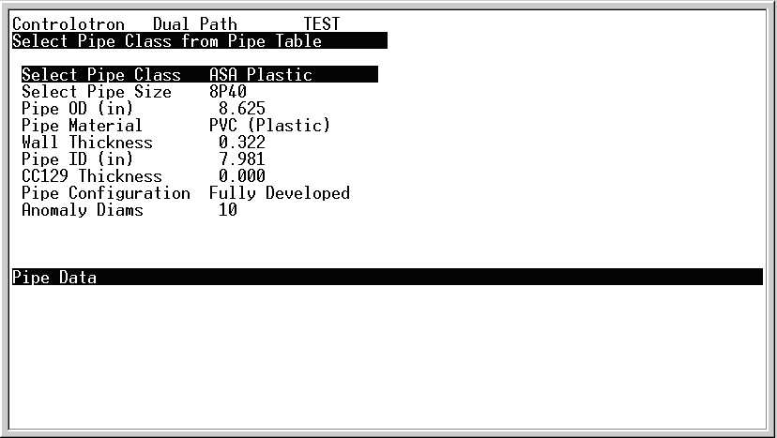

13. “Select Pipe Size” should show “N/A”

14. “Pipe OD (in)” put in exact pipe OD (i.e. 8.625 in.)

15. “Pipe Material” if pipe is not Steel scroll down to appropriate material

16. “Wall Thickness” put in Exact Wall thickness (i.e. 0.322 in.)

17. “Pipe ID (in)” is calculated

18. “CC129 Thickness” is the thickness of damping material put on pipe. See table below. This is for the clear layers (Soundcoat). This material costs $30 per foot and is custom aerospace material. Window sealer and Grace Shield (De-Icer) (Roofing Tar Rolls) found at Home Depot work just as well. Many agree that the Home Depot products work better than the expensive Soundcoat. Use automotive break cleaner fluid on the sticky section and it will peel off afterwards without being permanently stuck there (and in some cases can be reusable). At higher pressures 400+ psi or so this dampening may not be needed. SOMETIMES, IT IS OK TO USE IT WITHOUT DAMPENING at any pressure if you can get it to lock up on a signal. For custody transfer accuracy, it’s probably a good idea to use it but not necessary. Also it helps in areas with a lot of noise. It is up to the user to make this judgment call and know the meter well enough to know when to use it or not. A Handbook Guide of when to use it or not does not exist. If you don’t have any dampening material, don’t wait until some arrives with it as it’s only partially necessary.

|  |
| --- |
| **Clear Layer Soundcoat Thicknesses**  **Transducer Size CC129 Layers Thickness**  B1H, B2H, B3H 0 0.000  C1H, C2H 1 0.027  D1H, D3H 2 0.054  D2H 3 0.081  D4H 4 0.108 |
| **Grace Shield Thicknesses (Roofing Tar)**  **Transducer Size Layers Thickness**  B1H, B2H, B3H, C1H, C2H 0 0.000  D1H, D3H 1 0.038  D2H 2 0.076  D4H 3 0.114 |

19. “Pipe Configuration”. Usually “Fully Developed” unless you see another item from the menu that fits.

20. “Anomaly Diameter”. Keep 10 there unless you see differently from where you are measuring.

20A. “ThermExpCoef 1/F”. Put this at 6.2.

20B. “Mod of Elast PSI”. Put this at 30.

21. “Left Arrow” to get out of this screen and back to the main menu screen.

22. “Down Arrow” to “Gas Parameters” screen and “Right Arrow” for screen below.

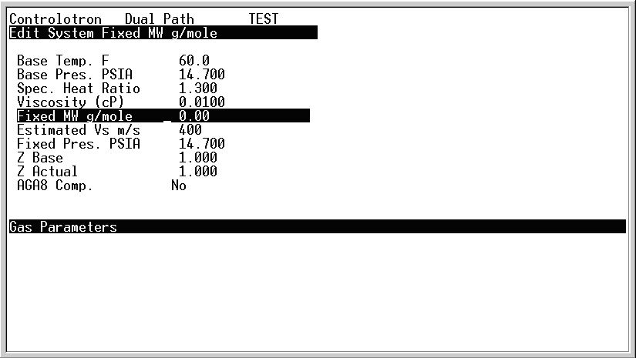

Example:

Z Base 0.997

Z Actual 0.910

23. The only thing you change here are “Z base” and “Z Actual”. Resist every possible urge to change the others (even speed of sound Vs). “Z base” is the compressibility factor of the gas at 60 F and 14.7 psia which is **0.997** (1.000 is close enough). “Z Actual” is the compressibility factor of the gas at the actual temperature and pressure you are running at (i.e. 80F and 746 psi). This value might range from **0.850 to 0.997.**

24. The accuracy of these numbers affects the accuracy of your final output in Standard Flow. So these numbers are best calculated from a chromatograph, Pipeline Technical Toolbox, or a compressibility calculator. You can estimate from a compressibility chart but you’re going to lose accuracy based on your eyeball guess. This means that if you guess a Z of 0.852 and it’s really 0.862 you are already off by 1%. This is a self induced human factor that affects the total accuracy at the end so this must be correct. When using Actual Flow Rates this is not significant, but when using Standard Flow Rates it’s the biggest factor of accuracy that you need. A compressibility calculator is the best tool (using the best numbers from a chromatograph). See the reference material.

25. “Left Arrow” out of the screen back to main menu and go down to “Pick Install/Xdcr” for screen below.

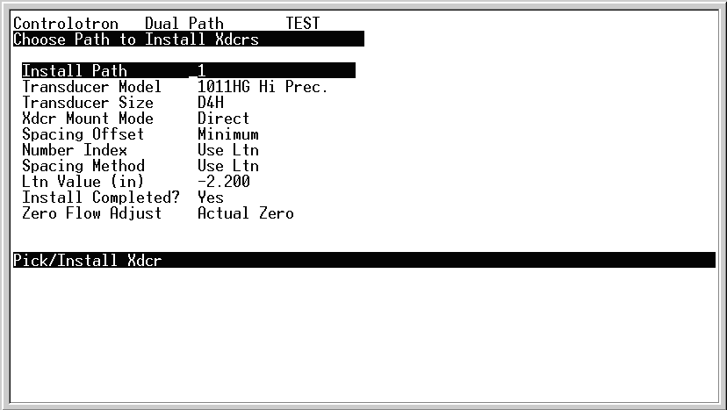

Reflect

Nominal

26. “Install Path” should remain “1” This means channel 1, these meters have 2 channels. Note that if you are performing check measurement for custody transfer or temporary custody transfer measurement, you will install both channels for added accuracy. This means that you will complete the setup and install for channel 1, then return to this step to complete the setup and install for channel 2. After installation, from the main menu you will use the “up arrow” to select channel 3. Viewing channel 1 means you get the data from channel 1. Viewing channel 2 means you get the data from channel 2. Viewing channel 3 means you get the data from the combination of channel 1 and channel 2.

27. “Transducer Model” stays at “1011HG Hi. Prec.”

28. “Transducer Size” hit “right arrow” and “down arrow” for options. See chart below for Transducer selection. Also notice on the top of the screen that it recommends a transducer for you (i.e. DH2). You must program the correct size for the transducers you are installing! Ignore the H or lack thereof. Just go by D2 when you see DH2 or D2H. It means the same thing.

**For Meters 01 & 02 (Older Models)**

**Transducer Min Wall Thickness Max Wall Thickness Min Diameter**

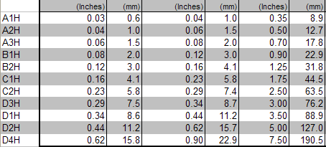

**For Meters 03 & 04 (Newer Models)**

**Transducer Min Wall Thickness Max Wall Thickness Min Diameter**

|  |  |  |  |
| --- | --- | --- | --- |
| **B2H** | **0.18** | **0.23** |  |
| **C2H** | **0.23** | **0.32** |  |
| **D1H** | **0.32** | **0.44** |  |
| **D2H** | **0.44** | **0.62** |  |
| **D4H** | **0.62** | **0.90** |  |

29. “Xdcr Mount Mode” change to “Reflect” Reflect means on Xdcrs on the same side, “Direct” means on the opposite sides.

30. “Spacing Offset” keep as “Nominal.”

31. “Index Number” is the number on the provided bracket rod to space the transducers. One bracket goes in the “Ref” hole and the other goes on the appropriate “index number”. If you’ve lost the rod, then the “Ltn Value (in)” is the physical distance you’ll have to measure (end of transducer to end of transducer not hole-to-hole, or Bracket-to-Bracket distance)

31A. Install CC129 damping compound of the correct thickness for the transducers in use, then mount the transducers and connect cables as you do this step.

32. “Install Completed?” hit “right arrow”, hit “down arrow” to “Install”, and select “Enter.” From this point you can press the “Alt” and “Menu” keys for 6 seconds until the ALC value is displayed in the upper tool bar. This value should be > 36 for the install to be successful. If this value is < 36 then make changes in location, dampening material, or transducers until the reading is satisfactory. Once the ALC is satisfactory, the transducers will install properly and the readings will be accurate. Once the ALC is > 36 then left arrow until you can get back to “Install Completed?” hit “right arrow”, hit “down arrow” to “Install” and select ”Enter.” Wait for 3-5 minutes for it to install. While waiting if you see “06” with dashes going across screen, that’s good. All other numbers are bad. Refer to the manual or reference material to troubleshoot if you see something other than 06. If the meter doesn’t connect and read, then you’ve got setup issues (i.e. wrong wall thickness, not enough pressure, too much turbulence, or a lot of noise). At this point it’s the physical setup or bad location rather than the meter. Double check everything then change locations or abort if you don’t have pressure over 125 psig (or too small of a pipe < 3 in.). In some cases the meter will not work no matter what you do to it because the location or setup is not fit for clamp-on measurement. This is a judgment call of the operator and at this point it’s advisable to use other tools and methods to find the flow (i.e. The Flow Velocity Calculator provided in the reference material).

32A. Here are some typical codes that really mean nothing. If you get anything other than 06, start looking in manuals for additional reading, then start calling the Siemens phone number. It is common to get these as this meter technology is new at reading Natural Gas and it is hard to lock onto a reading.

|  |  |  |
| --- | --- | --- |
| 1. 4 Cycle ALC Makeup 2. E/L Makeup 3. Place Holder (Not Used) 4. Place Holder (Not Used) 5. Correlation Makeup 6. Normal Measurement State 7. Damping Buffer Low Level | 1. Damping Buffer High Level 2. Damping Buffer Settling 3. Normalized Buffer Amplitude Failure 4. Envelope Peak Value Error 5. Tn Projection Compute Error 6. Tn Projection is Too Early | 1. Tn Projection is Too Late 2. Envelope Signature Failure 3. Correlation Can’t Converge 4. ZeroMatic absolute delta T Correlation Error 5. Correlation Settling 6. Window Movement (settling) |

33. When “measured velocity 1325 ft/s” shows up hit “left arrow” and wait through setup. It will be around 1325 ft/s give or take. This is “speed of sound” through the compressed gas not “gas flow velocity”. Air is around 1100 ft/s.

**CONGRATULATIONS THE METER IS CONNECTED AND NOW READING**

34. “Left arrow” to go the main menu

35. “Down arrow” to “Flow/Total Units” then “right arrow” for screen below.

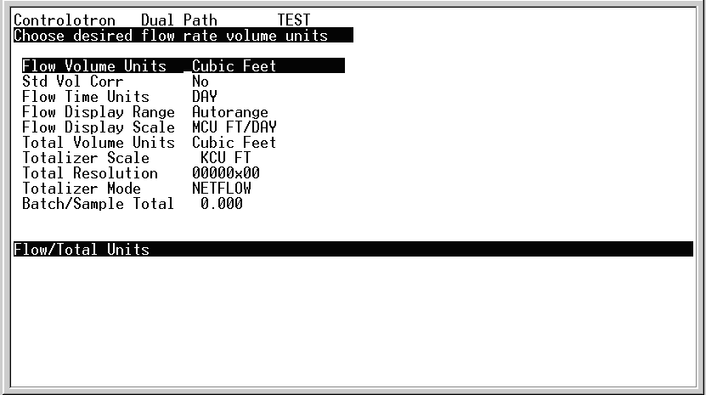

36. “Flow Volume Units” set to “Cubic Feet”

37. “Std Vol Corr” set to “Yes”

37A. When reading Actual Volumes keep this at a “No” (i.e. for meter checks). It is up to the user to know the difference between Actual and Standard volumes as this affects the use of this meter and its modules.

38. “Flow Time Units” set to “Day” and “Flow Display Scale” set to “MCU FT/DAY” (MMCUFT/DAY for the newer software.

39. All others leave the same.

40. “Left Arrow” back to main menu. “Right Arrow” on “I/O Data Control” for screen below.

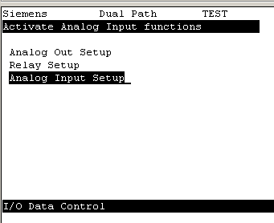

41. “Right Arrow” on “Analog **Input** setup” for screen below.

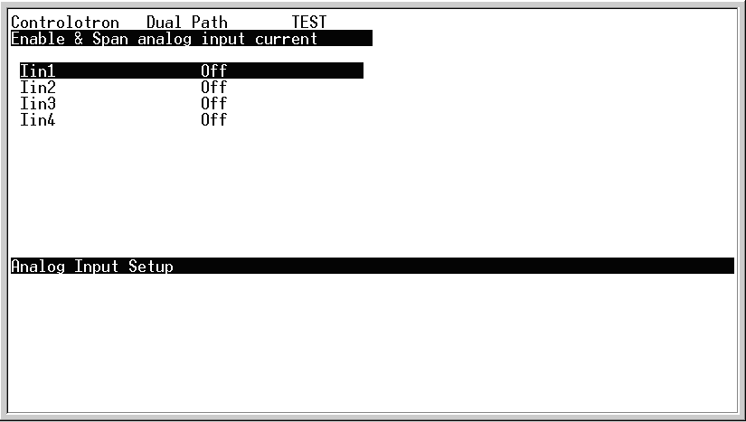

1. “Right Arrow” on “Iin1” and “Right Arrow” again for screen below and put to “PSIA”.

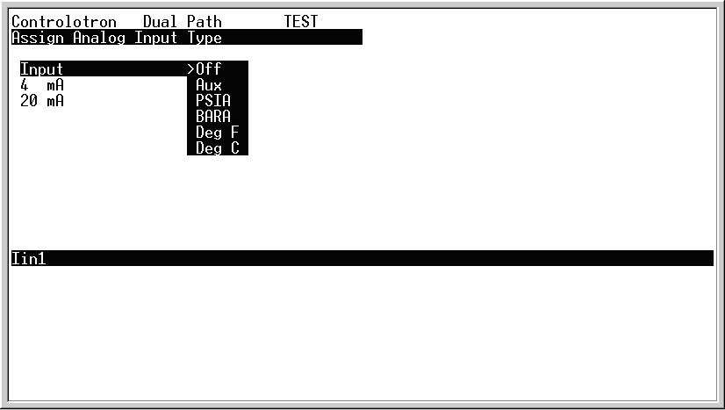

43. Insert total gas pressure into **BOTH** “4 ma” and “20 ma” input.

(i.e. 645 psig + 11.71 psia = 656.71 psia) for **BOTH** of them. You’re tricking the 4-20 ma inputs and telling them to stay fixed.

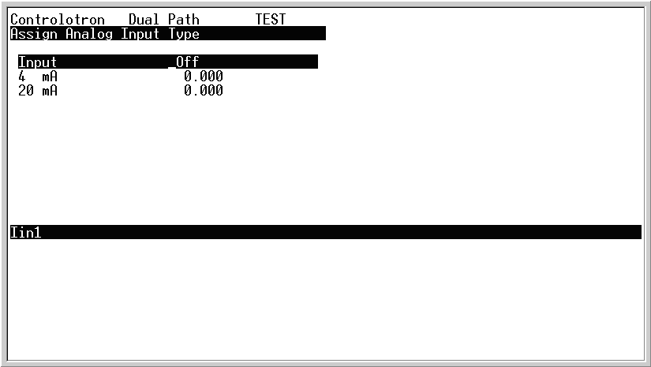

PSIG

656.71

656.71

44. Do same for temperature input using “Iin2” and putting in temperature (in F) for **BOTH** “4ma” and “20ma” inputs. As the pressure and temperature change throughout the measurement you must change **BOTH** periodically. RTD inputs and Pressure Taps can be wired in if desired for real-time measurement (this is more for a permanent installation).



Deg F

78

78

**FINALLY**

45. To see what you are flowing go back to main menu screen and “right arrow” on “Diagnostic Data”.

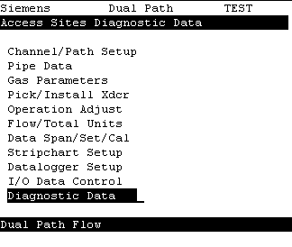

46. Make sure “Path Select” is on “1”. It has a tendency to shift to “Default is Path 1 & 2”. This is a software flaw.

47. “Right arrow” on “Flow Data” and the top 2 numbers are what you want.

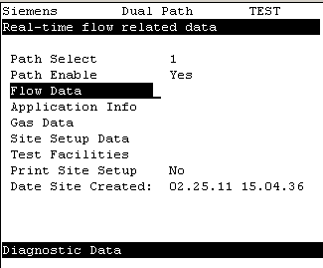

1. This is a sample of what you might see. When you question your setup, a “Valc %” reading of 30 or more means you did it right. That means the transducers are talking.

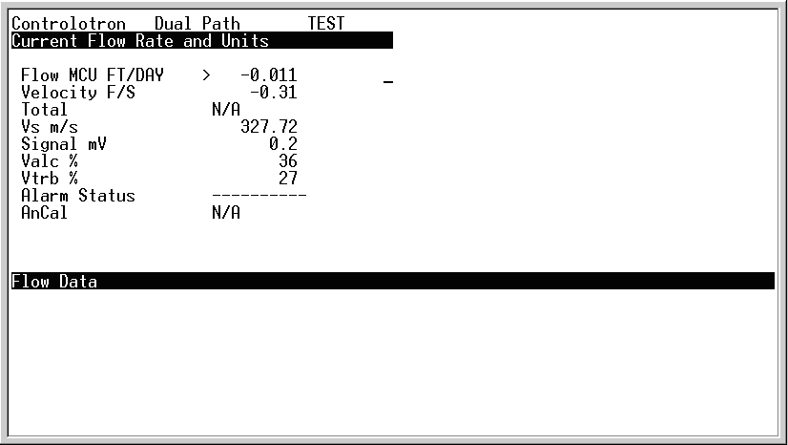

48A. Alternatively, press MENU to exit to the flow display screen to observe flow rate. The meter will prompt you to “Save the Site”, press “right arrow” & “Enter” to save the now-complete site and exit to the display screen

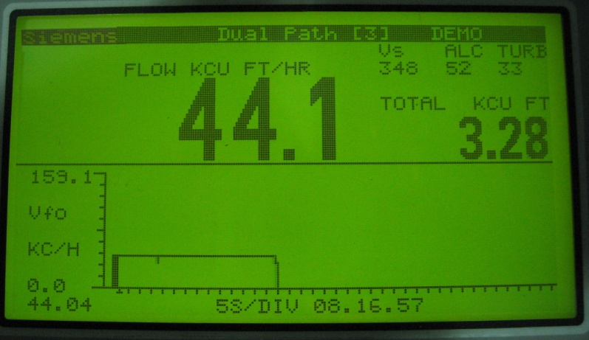

49. You’re Done. The screen “Test Facilities” below requires additional help and isn’t needed at this time. They are for additional troubleshooting and verification that the flow profile and signals are acceptable.

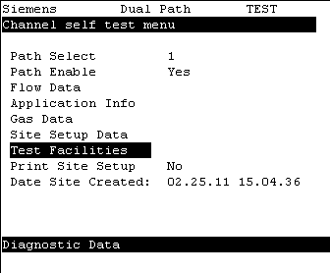

**For 24 Hour 7 Day Technical Support, Call Siemens at 1-800-241-4453.**

or **1-800-333-7421.**

Mark Hullinger (801)-584-6734 office

(801)-554-3737 mobile

Casey Seely (801)-584-6414 office

(801)-349-6583 mobile

Alan Mathews (801)-584-6814 office

(801)-580-0556 mobile

**APPENDIX**

**Siemens Controlotron Si-Trans Cable & Transducer Testing**

1. Put a Voltmeter on the Ohm setting and measure resistance across the center pin and the outer metal shielding.
2. Connect any transducer to one end of the coax cable and measure the resistance on the other end.
3. It will look like this:

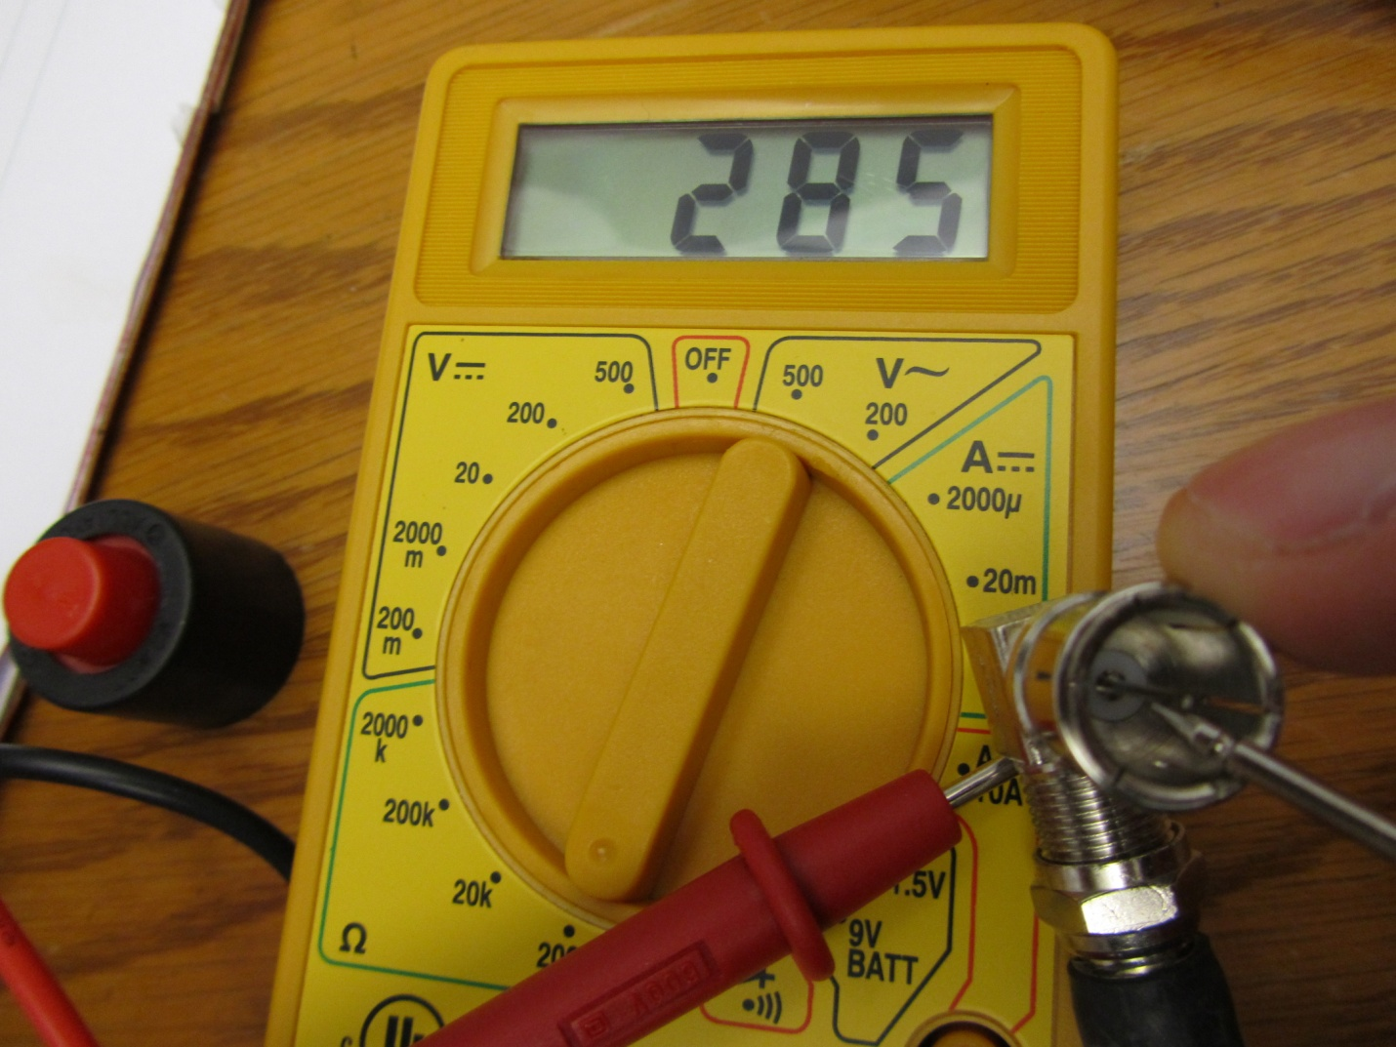

**Transducer Measured Resistance**

B1 133 ohms +-5

B2 133 ohms +-5

C1 282 ohms +-5

C2 282 ohms +-5

D1 282 ohms +-5

D2 1033 ohms +-5

D4 1033 ohms +-5

**Transducer Cable Specs**

Belden 9269

RG-6A/U 1C22 Shielded 92 ohm

RG-6 75 ohm

**Desktop Setup to Verify that Meter and Transducers are Reading Properly**

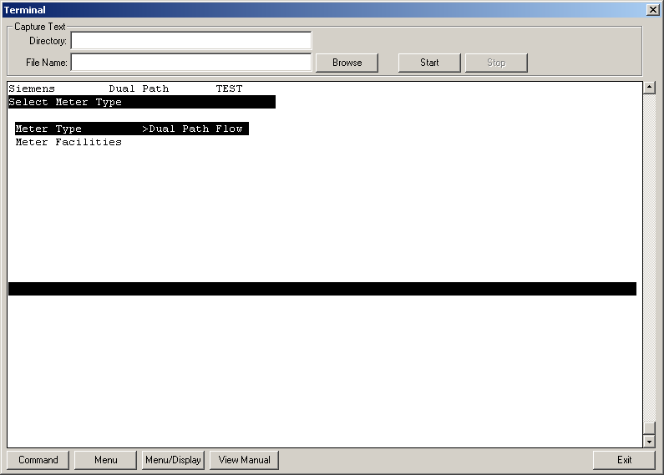

Create a new site called TEST

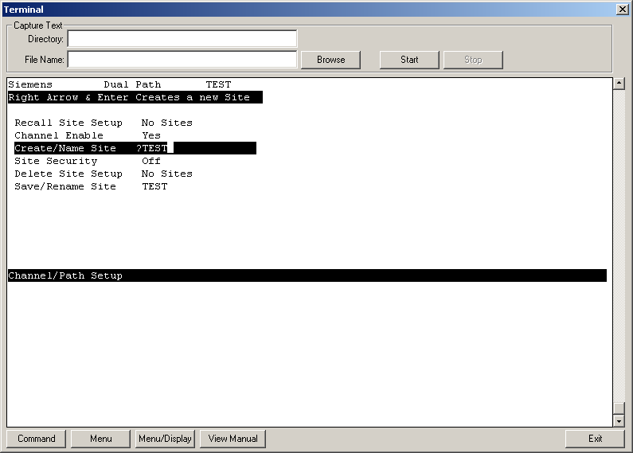

Configure transducers as such. Negative number means overlap which is what you want.

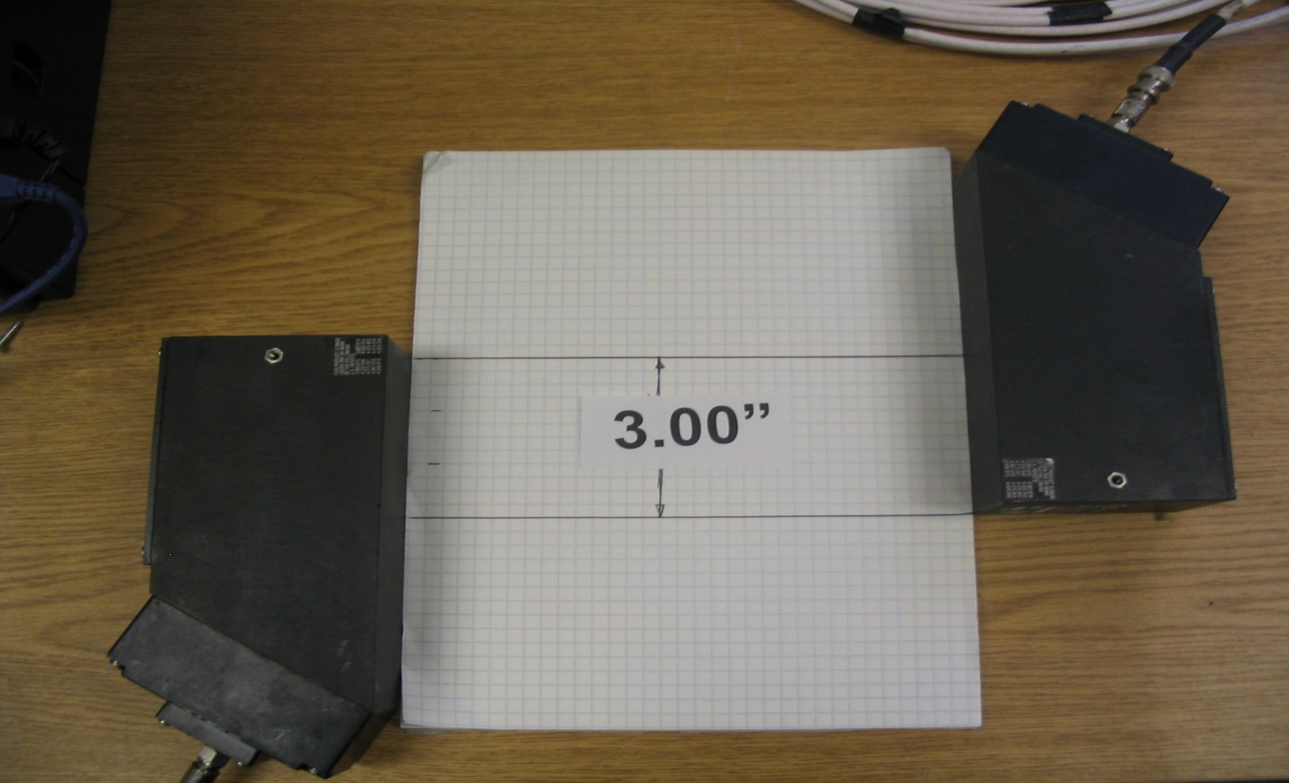

Main Menu, Pipe Data

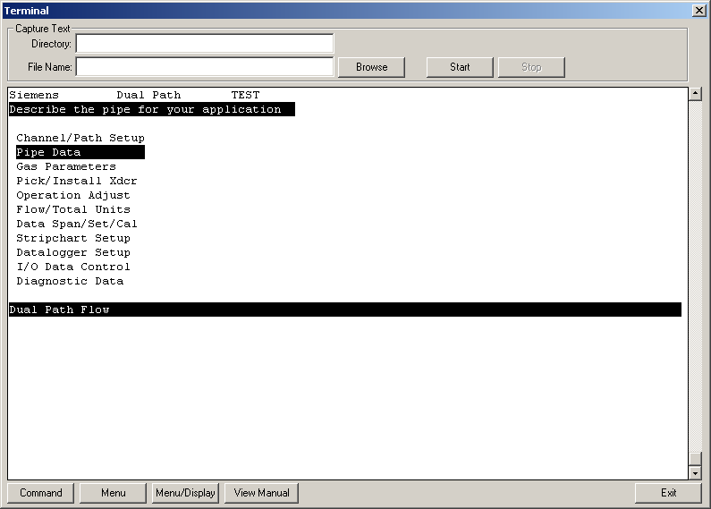

Choose ASA Plastic

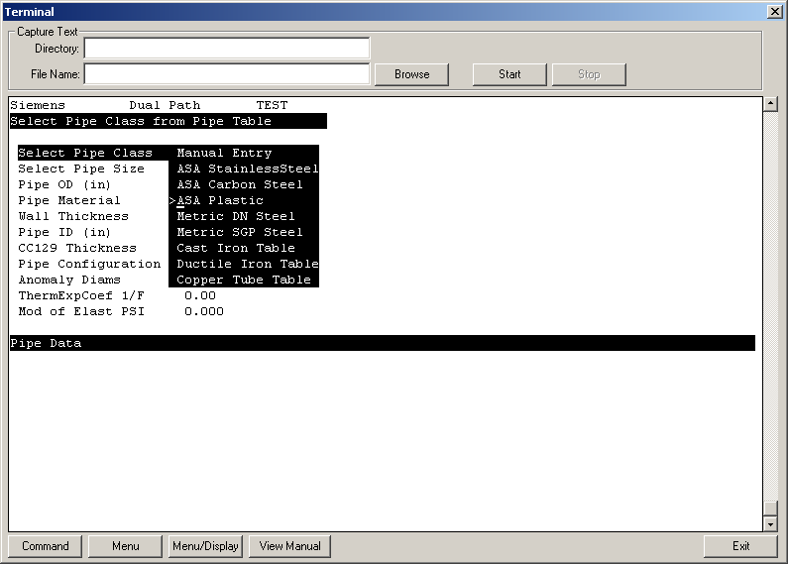

Choose 8P40. 8” schedule 40. This is 8.625”. This is because a sheet of paper is about 8.5 and you can use this setting.

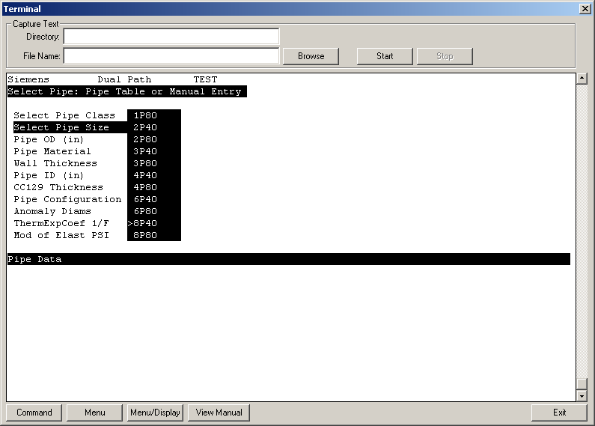

PVC Plastic

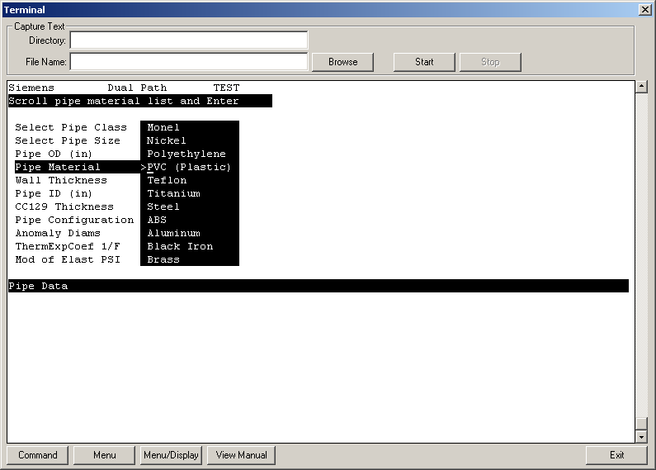

Wall thickness, keep at 0.322”. This really doesn’t matter. Keep everything else the same.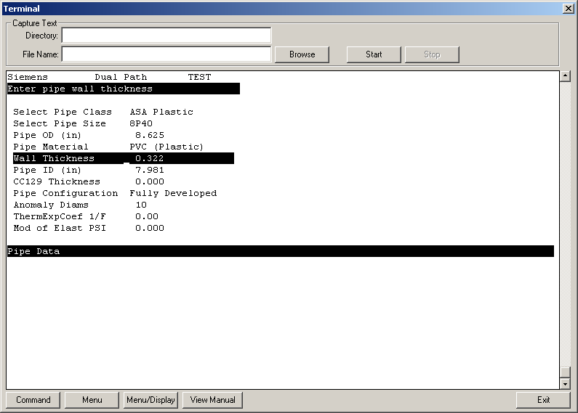

Go to Main Menu , then Pick/Install Xdcr

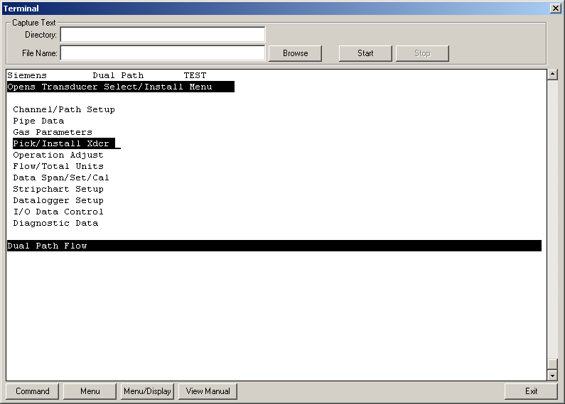

Select D1H transducers or whatever ones you are using.

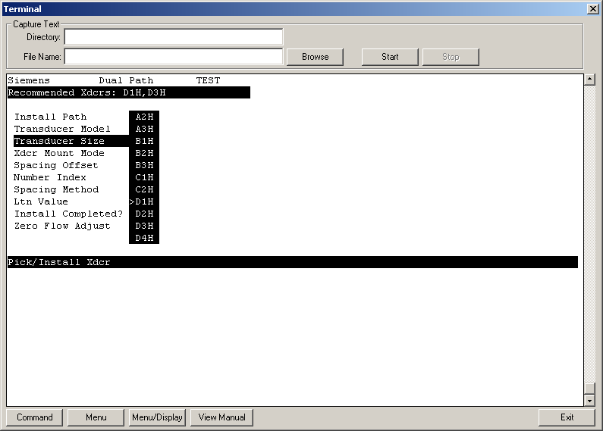

Direct Mount

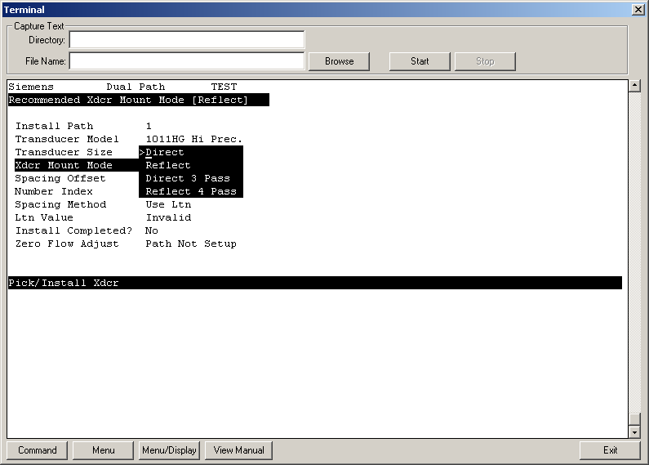

Notice that Ltn is -3.2”. Exactness doesn’t matter here even though the picture above says 3”.

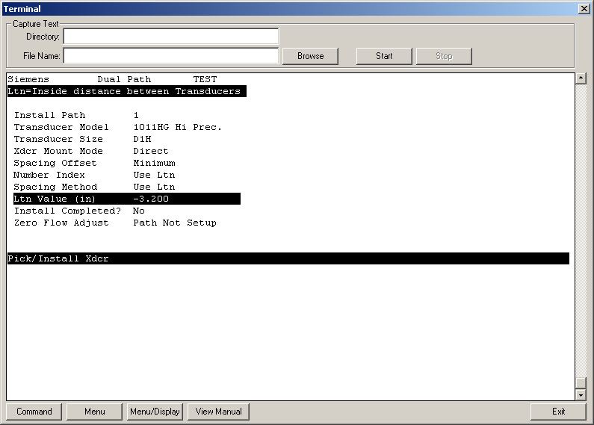

Install Completed? Then Install

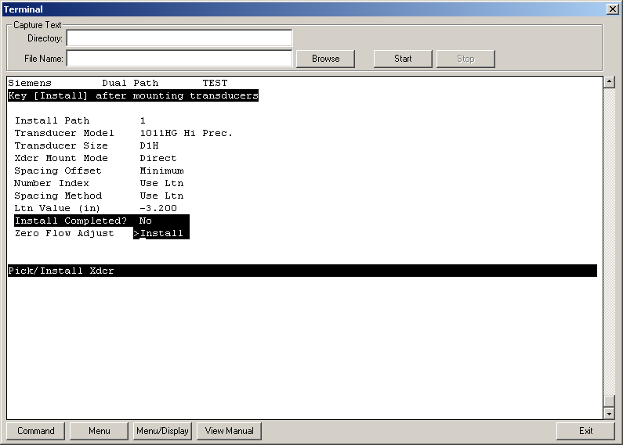

ALT-Menu force transmits the transducers. What this means is that you want the ALC above 30. You can move the transducers around until you get a number above 30 (or the highest number possible).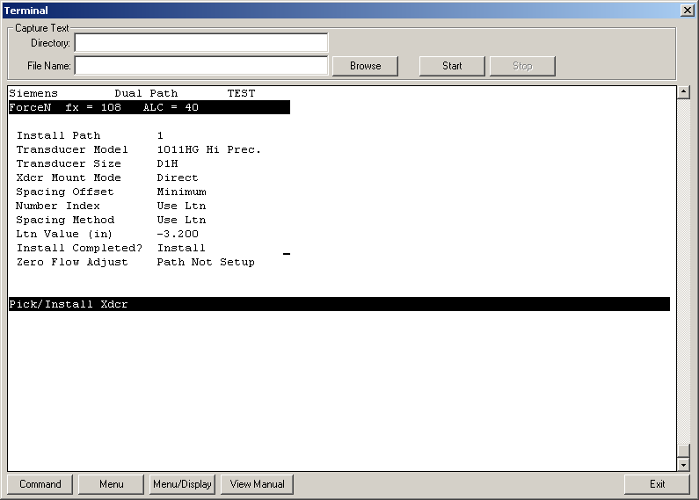

06:------------ is good and any other number is bad. Drive number does not matter. Measured Vs shows up. Hit right arrow and enter

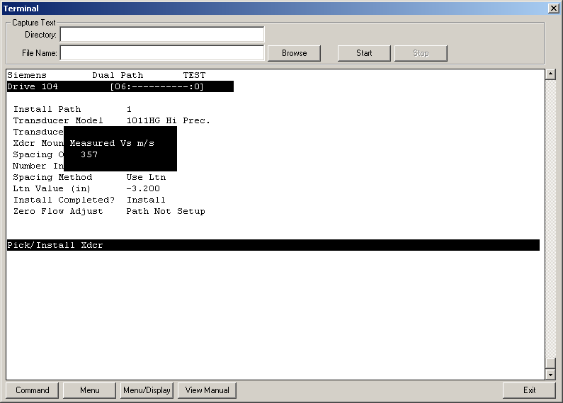

Then go into Main Menu, Diagnostic Data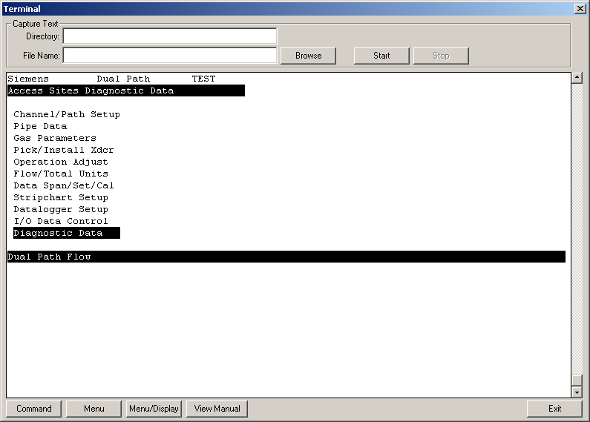

Flow Data

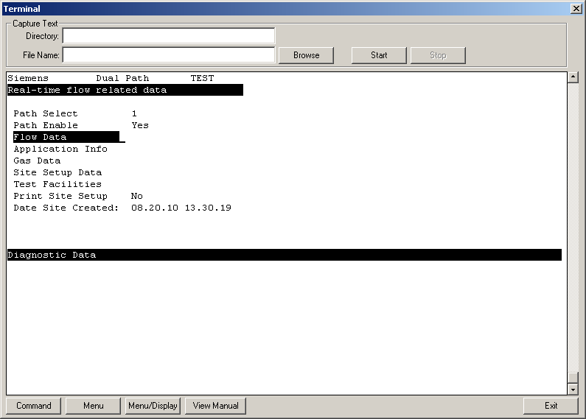

Here’s your flow data. Fan a piece of paper between the transducers or blow and watch the flow change.

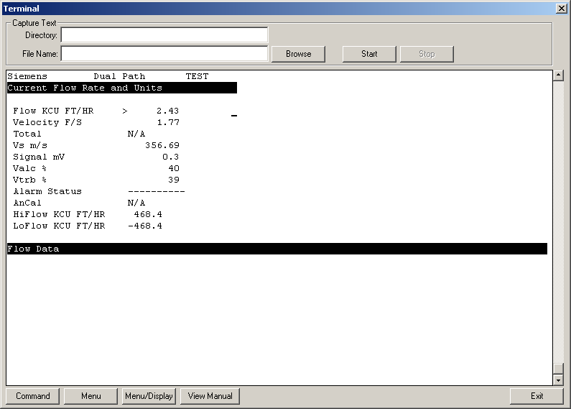

Go back and save your site. Enter

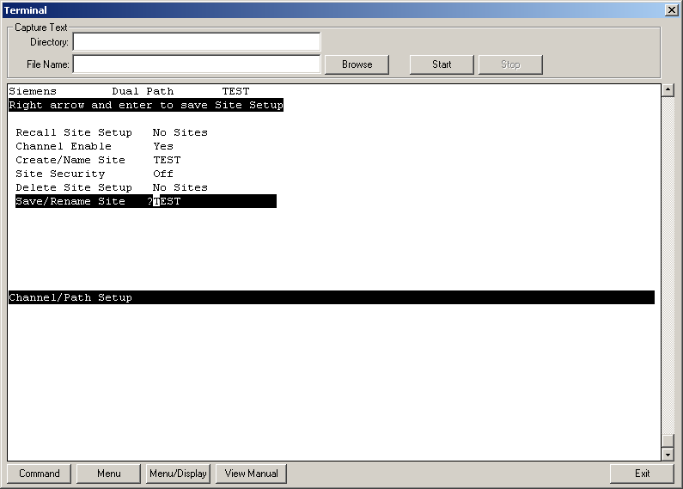

**Siemens Controlotron Si-Trans Power Testing**

This is to check the unit for proper power to see if it’s functioning properly.

1. Take off the cover on the right side and locate the top right corner on the mother board.

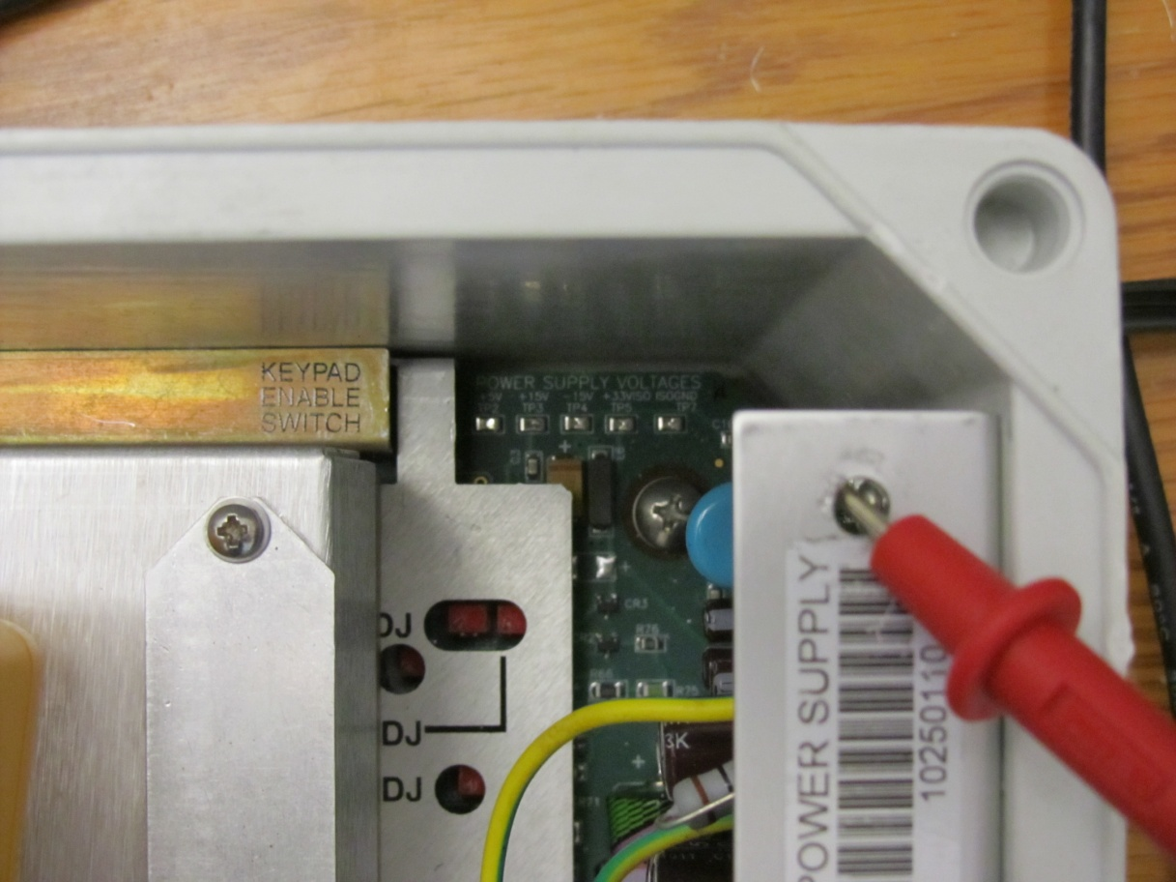

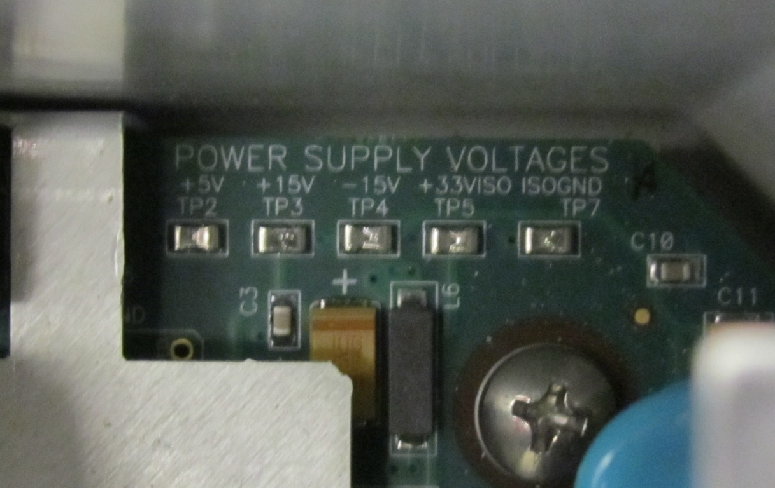

1. Notice the +5V , the +15V, and the -15V nodes.
2. Put a DC voltmeter on the +5V and it should read close to 5 volts +- 0.5
3. Put a DC voltmeter on the -15V and it should read close to 15 volts +- 0.5
4. Put a DC voltmeter on the +15V and it should read close to 15 volts +- 0.5

